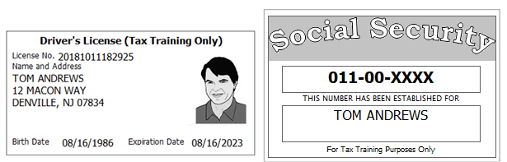

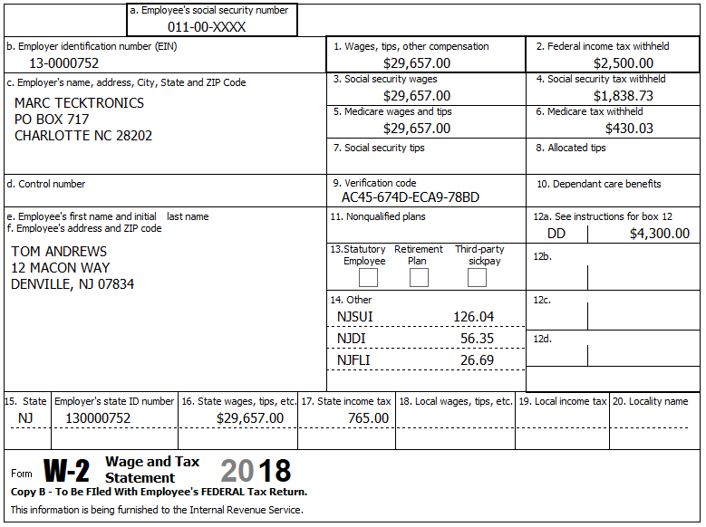

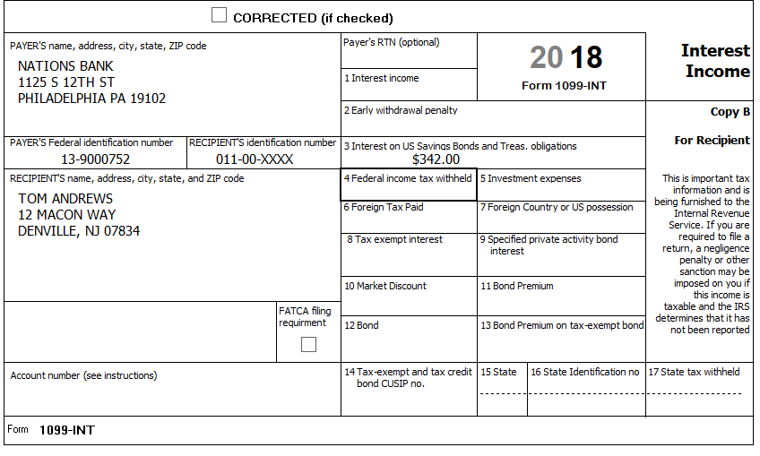

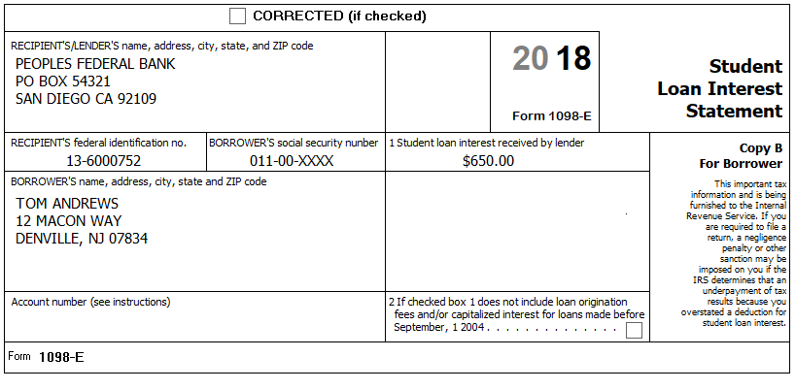

Other Information:
- Tom paid $745 in medical expenses for dental work.
- Tom donated $100 to United Fund
- Tom paid $300/ month rent for the entire year

